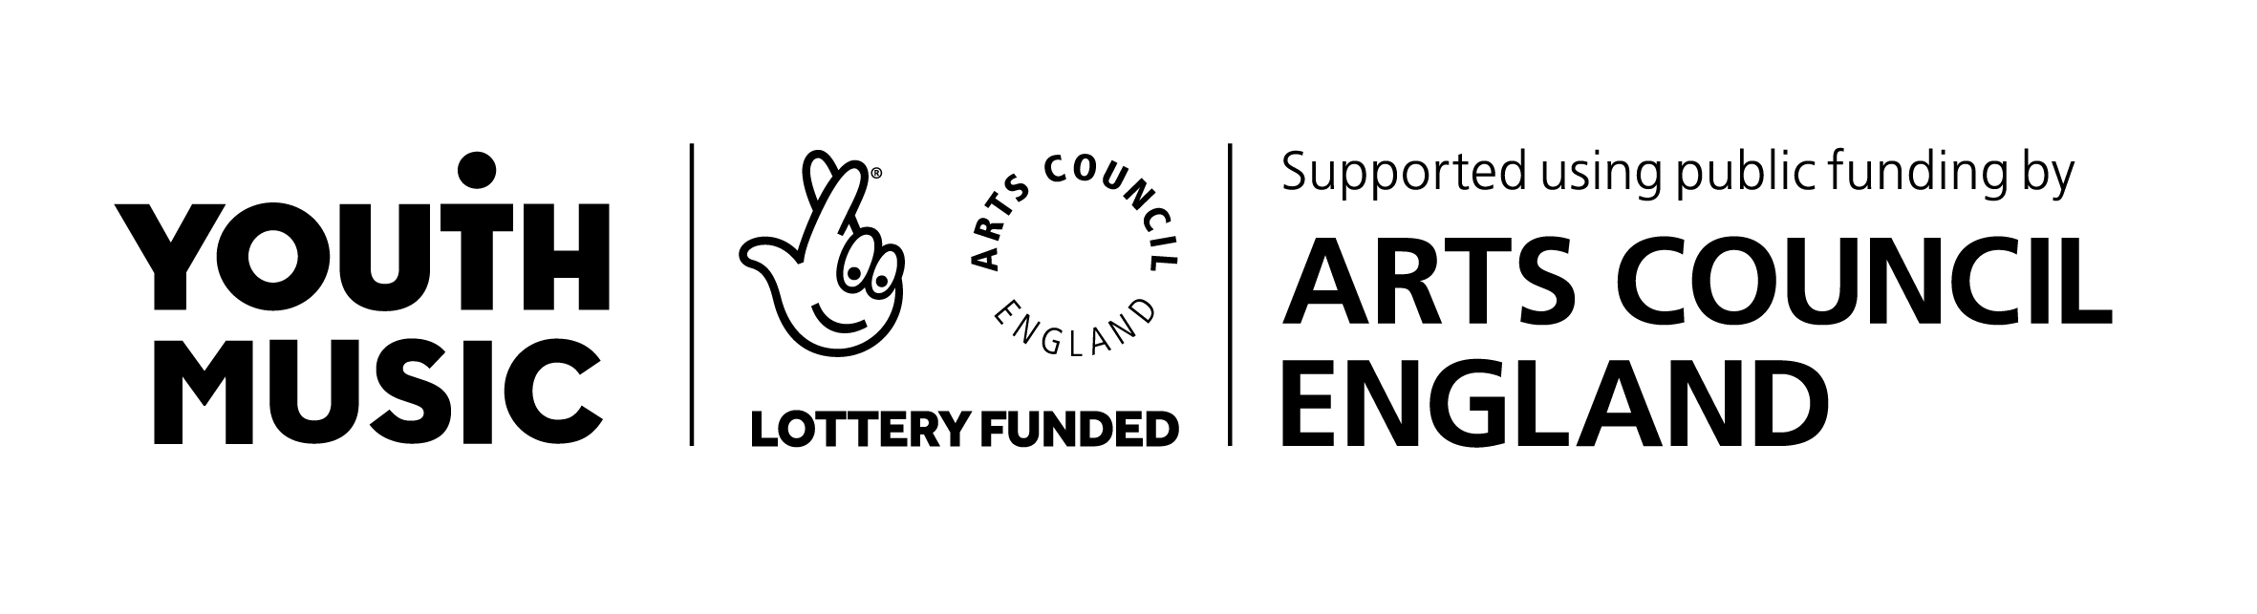
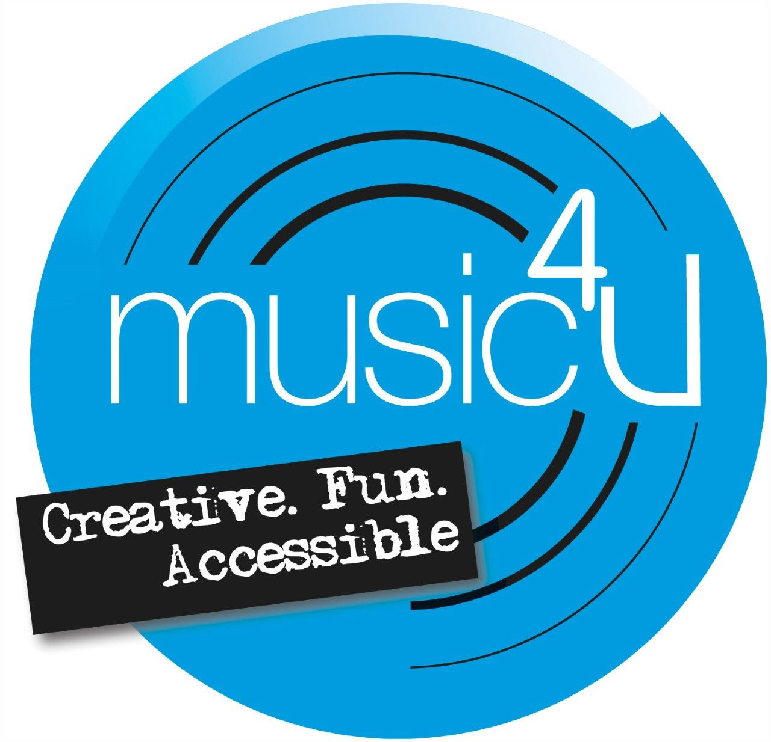

Music4U Photograph and Video Permission Form for ‘I Can Download and Play!’

Description:

During the Covid-19 crisis, the National Centre for Early Music (NCEM) has been working to develop some online musical resources for our Youth Music funded Music4U project. As part of this we have developed I Can Download and Play!, a series of resources suitable for D/deaf children and young people. As part of this project, young people are welcome to share and send any video clips, pictures or creative responses they have had to the resources, via email and WeTransfer.

Photograph and Video Permission:

Photographs, video clips or any other type of submissions, may be shared on the NCEM’s website and social media channels. Submissions would also be included in any showcase videos we create to celebrate all the young people that have taken part. This would also be shared on the NCEM’s website and social media channels.

Please indicate (by circling below) whether or not you give permission for photographs/ videos of your child / children to be used in this way.

Name of Child / Children:

Photograph and Video Permission: YES / NO

Name and signature of Parent / Guardian:

If you are unable to print and sign this document, then we will accept electronic signatures.
Alternatively, we will accept a video clip of yourself giving permission for your child/children to submit their responses, please state the following:
“I give my permission for photographs and videos of (name of child/children), to be used in this way. My name is….. and the date is….. ”.

Please send permission forms/videos with your child’s creative submissions on WeTransfer to education@ncem.co.uk .
This information will be shared with staff at NCEM and Music4U.

